Colors

* I like this brown/tan and greens and light purple

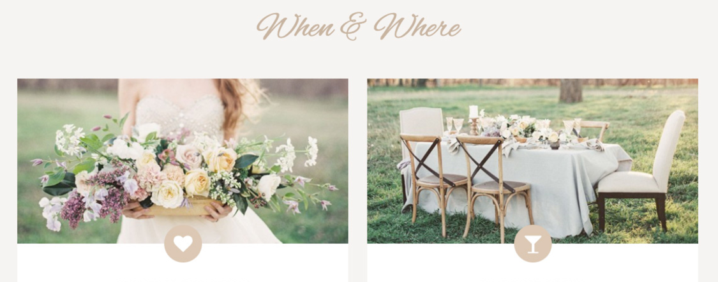

* Watercolor type look/background

First page

* Do we want a close up, or a representative further away photo?
* Find a little graphic
  + 
* Button for:
  + Just take me to the photos
  + Where am I supposed to be, and when?
  + Let us know you’re coming

About Us section

Timeline (either like this, or by year grouped)

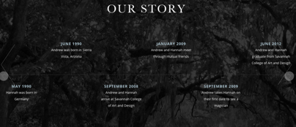

* Broken out by person story too
  + 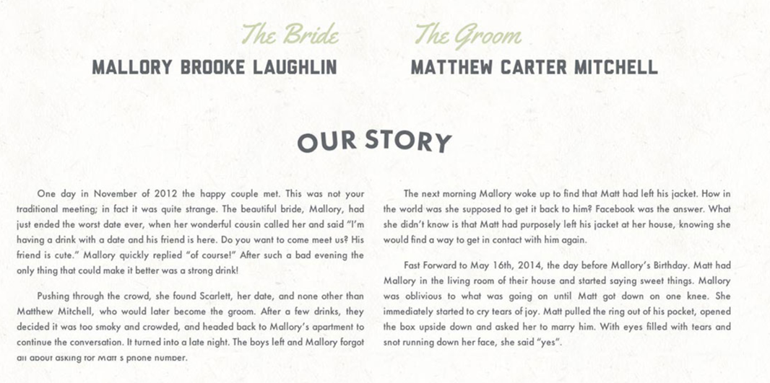
  + 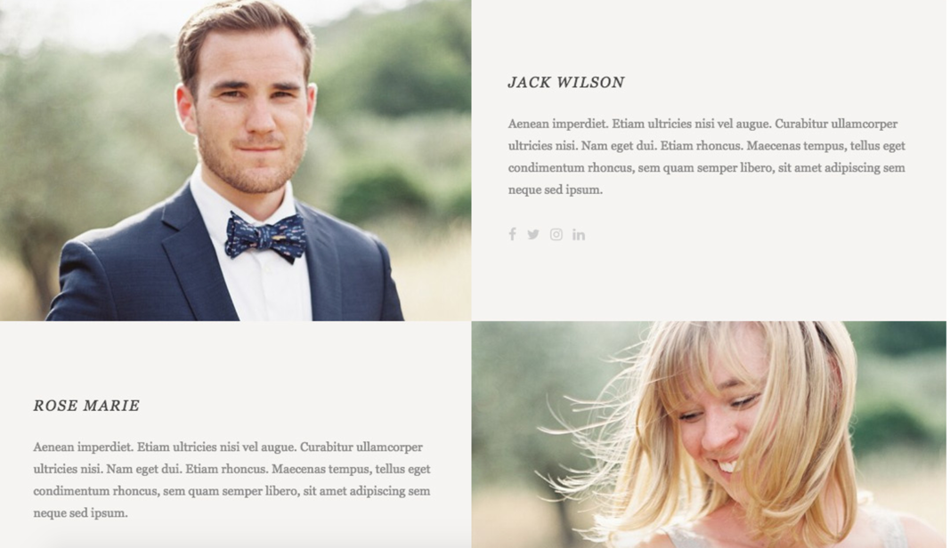

Wedding details section

* What you will and won’t see at our wedding
* Photo of the venue
* Nice layout for locations
* [This site](http://celebr8with.us/#eat) is a google example of the details section having buttons to jump further down to the different sections
* 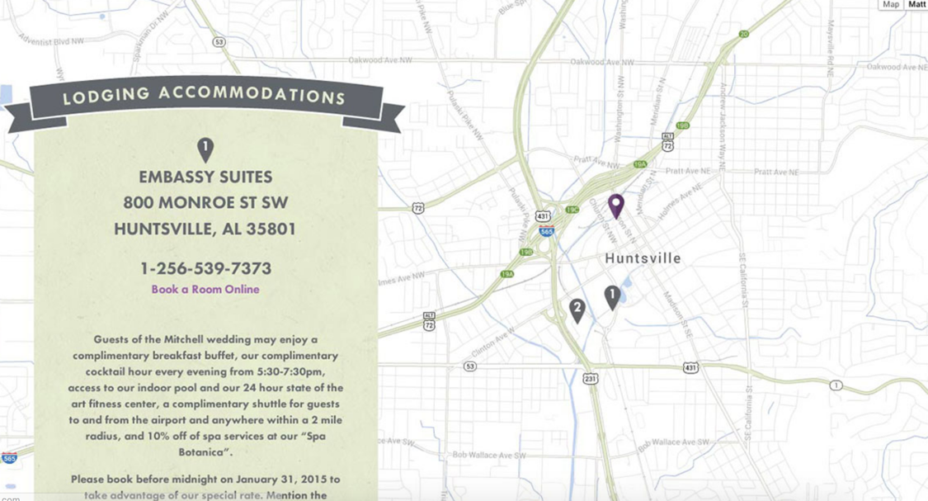
* 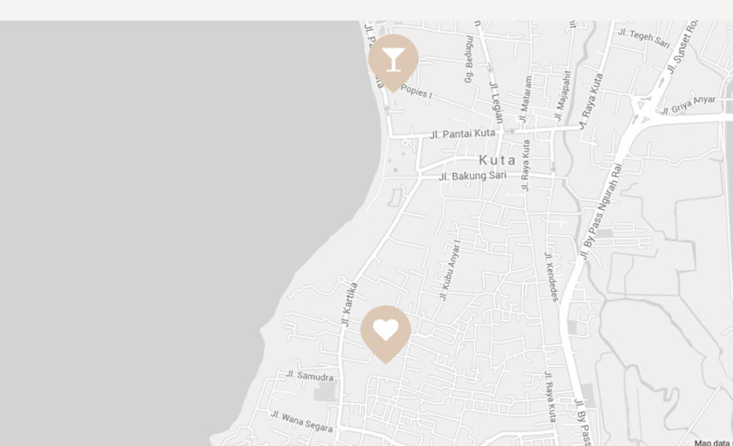
* 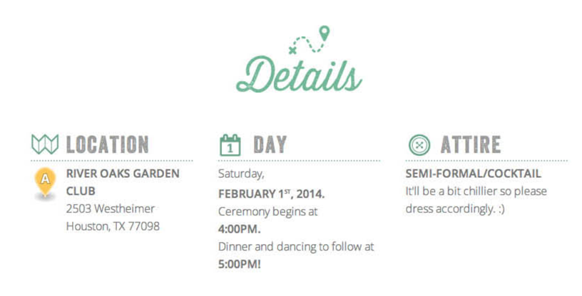
* Marking some of our favorite places for people to eat, shop, drink, etc
  + 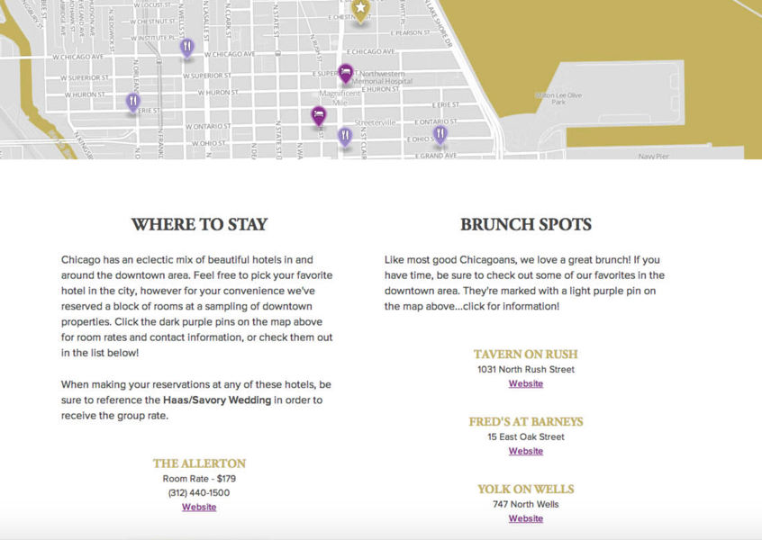

RSVP section

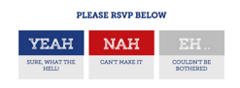

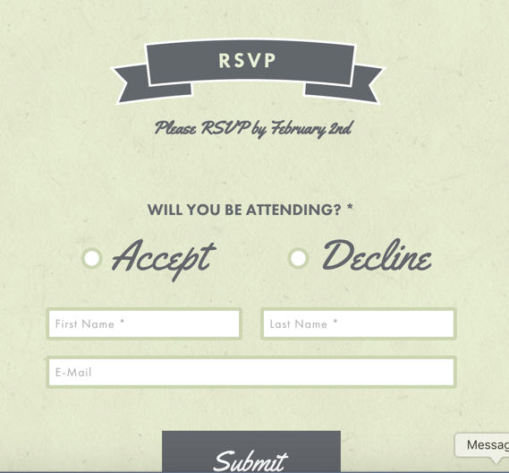

Photos

* 